**INFO 6205**

**Program Structures & Algorithms**

**Fall 2020**

**Assignment 3**

* **Task**

Step 1:

(a) Implement height-weighted Quick Union with Path Compression. For this, you will flesh out the class UF_HWQUPC. All you have to do is to fill in the sections marked with // TO BE IMPLEMENTED ... // ...END IMPLEMENTATION.

(b) Check that the unit tests for this class all work. You must show "green" test results in your submission (screenshot is OK).

Step 2:

Using your implementation of UF_HWQUPC, develop a UF ("union-find") client that takes an integer value n from the command line to determine the number of "sites." Then generates random pairs of integers between 0 and n-1, calling connected() to determine if they are connected and union() if not. Loop until all sites are connected then print the number of connections generated. Package your program as a static method count() that takes n as the argument and returns the number of connections; and a main() that takes n from the command line, calls count() and prints the returned value. If you prefer, you can create a main program that doesn't require any input and runs the experiment for a fixed set of n values. Show evidence of your run(s).

Step 3:

Determine the relationship between the number of objects (n) and the number of pairs (m) generated to accomplish this (i.e. to reduce the number of components from n to 1). Justify your conclusion.

* **Output** (few outputs to prove relationship)

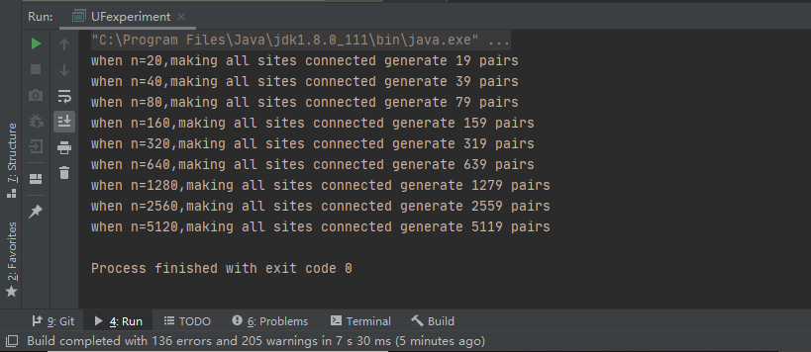

* **Relationship conclusion**

When we have value N as the number of sites(N), the number of pairs (m) generated to accomplish this (i.e. to reduce the number of components from N to 1) is always equal to N-1.

* **Evidence to support relationship** (screen shot and/or graph and/or spreadsheet)

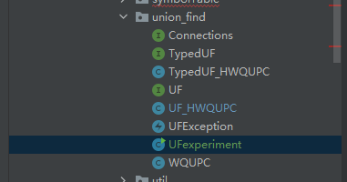

I create a new class named UFexperiment as a main class to do my experiment.My code as follow.

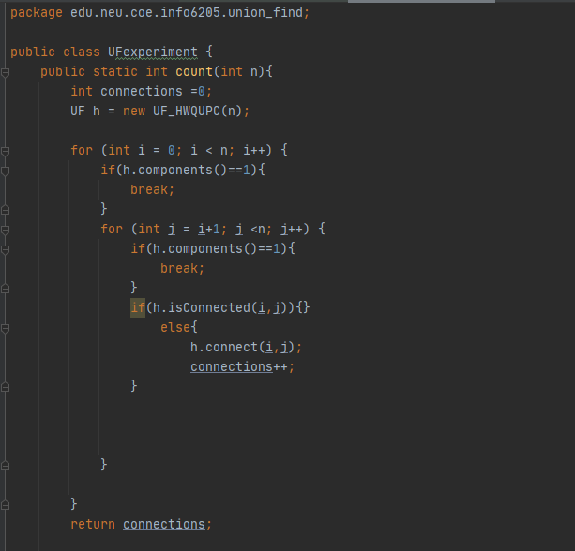

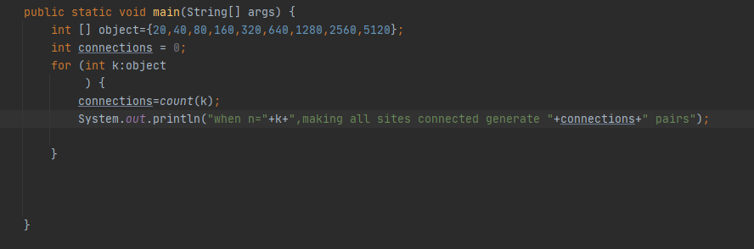



Beside,the output prove that m=N-1 .

* **Screenshot of Unit test passing**

